Supplement of New Insights From The Jülich Ozone-Sonde Intercomparison Experiments: Calibration Functions Traceable To One Ozone Reference Instrument

Herman G.J. Smit1, D. Poyraz2, R. Van Malderen2, Anne M.Thompson3,4, David Tarasick5, Ryan M. Stauffer3, Holger Voemel6, Bryan Johnson7, Deborah E. Kollonige3,8

1Forschungszentrum Jülich, Institute of Energy and Climate Research IEK-8: Troposphere, Jülich, 52425, Germany

2Royal Meteorological Institute of Belgium, Uccle (Brussels), 1180, Belgium

3Atmospheric Chemistry and Dynamics Laboratory, NASA/GSFC, Greenbelt, MD, USA

4Joint Center for Earth Systems Technology, University of Maryland Baltimore County, Baltimore, MD, USA,

5Environment and Climate Change Canada, Downsview, ON, Canada

6National Center for Atmospheric Research Earth Observations Laboratory, Boulder, CO, USA

7Global Monitoring Laboratory, NOAA Earth System Research Laboratory, Boulder, CO, USA

8Science Systems and Applications, Inc,

*Correspondence to*: Herman G.J. Smit (h.smit@fz-juelich.de)

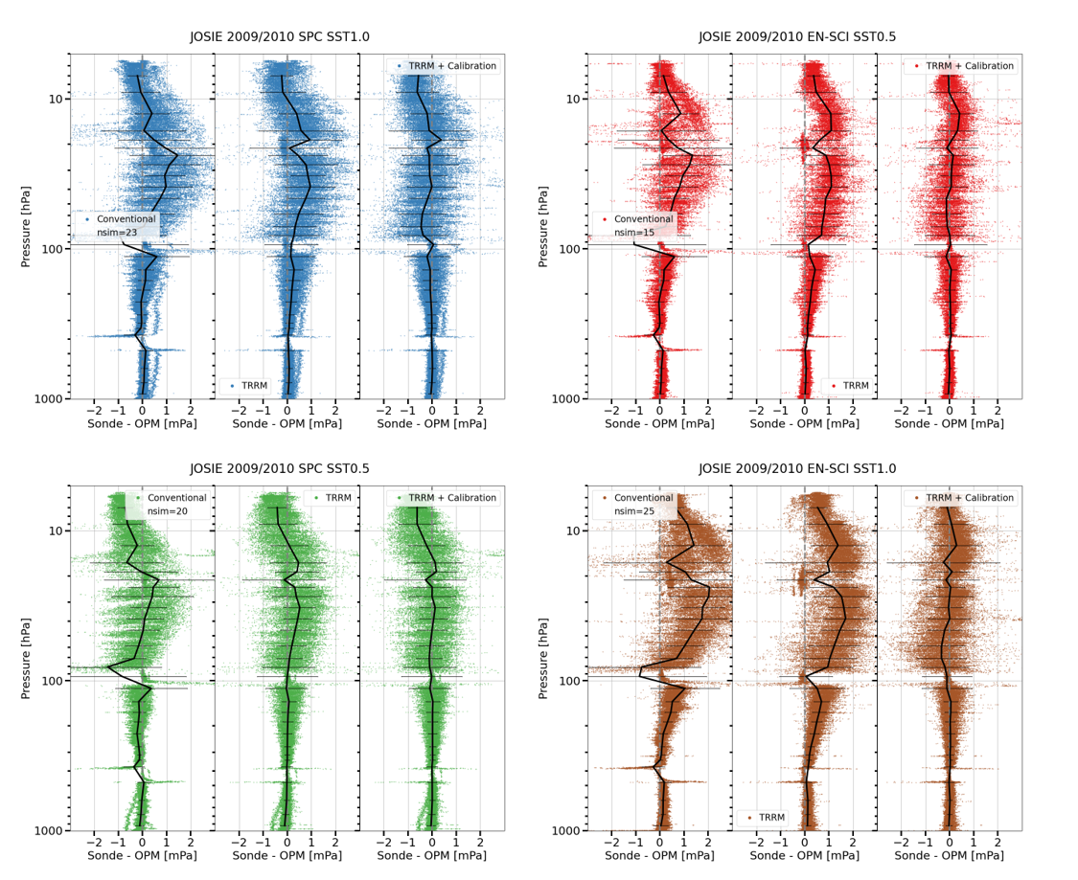

Figure S. JOSIE 2009/2010: Absolute differences [mPa] with the OPM for the “conventional” (left diagrams), “TRRM” (middle diagrams), and “TRRM + application of calibration functions” processed ozonesonde profiles for four pairs of sonde type and SST, shown as scatter plots in four different colors in the panels A-D: SPC6A/SST1.0 (A: blue dots), EN-SCI/SST0.5 (B: red dots), SPC6A/SST0.5 (C: green dots), and EN-SCI/SST1.0 (D: brown dots), respectively. In each diagram for both methods the mean and 1σ-standard deviation of the absolute differences are included (solid black line).

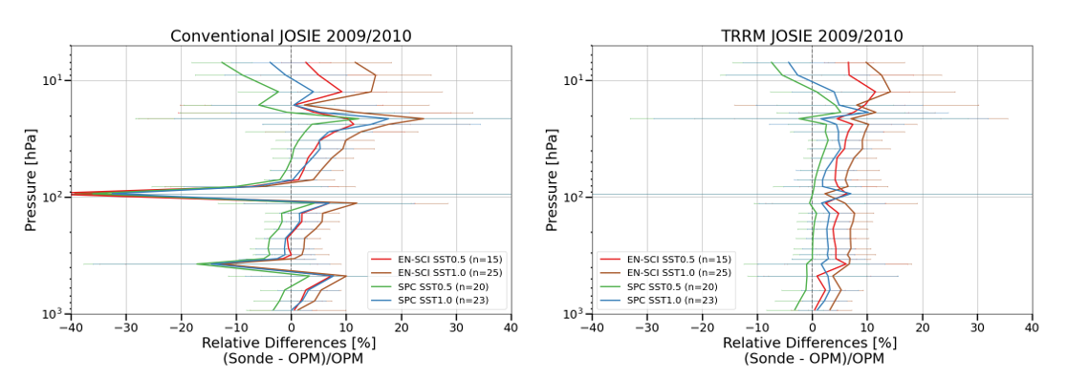

Figure S2. JOSIE 2009/2010: Summary of the mean relative differences with the OPM for the conventional (left diagram) and TRRM (right diagram) processed ozonesonde profiles for four pairs of sonde type and SST: SPC6A/SST1.0 (blue line), EN-SCI/SST0.5 (red line), SPC6A/SST0.5 (green line), and EN-SCI/SST1.0 (brown line). The 1σ-standard deviations are represented by the horizontal lines at the pressure grid levels.

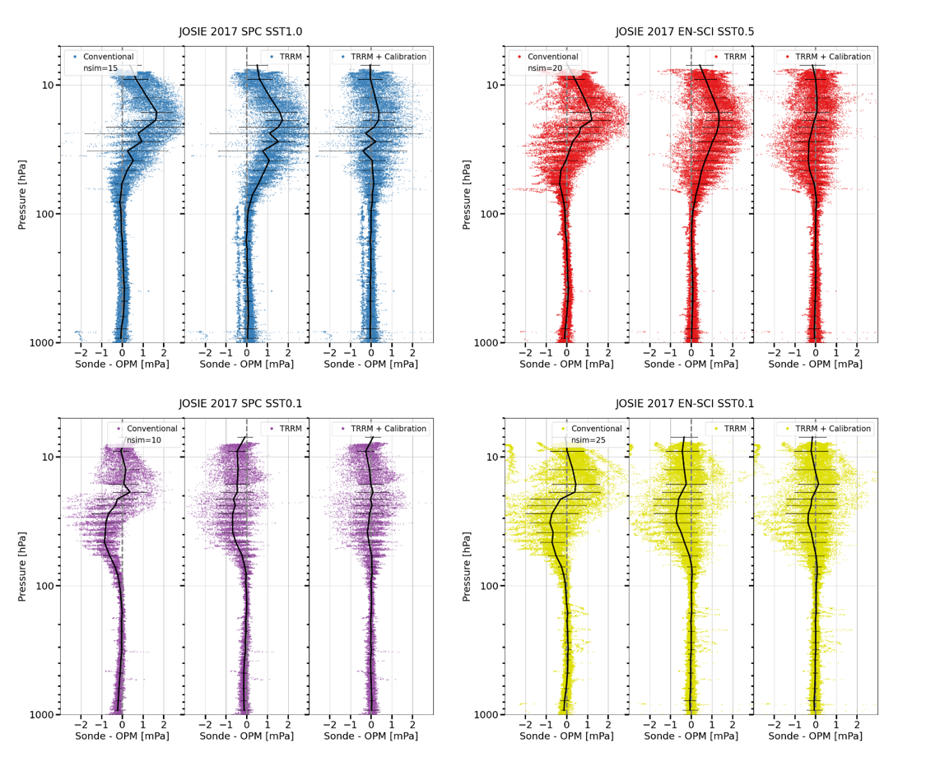

Figure S3: JOSIE 2017: Absolute differences [mPa] with the OPM for the “conventional” (left diagrams), “TRRM” (middle diagrams), and “TRRM + application of calibration functions” processed ozonesonde profiles for four pairs of sonde type and SST, shown as scatter plots in four different colors in the panels A-D: SPC6A/SST1.0 (A: blue dots), EN-SCI/SST0.5 (B: red dots), SPC6A/SST0.1 (C: purple dots), and EN-SCI/SST0.1 (D: lemon dots), respectively. In each diagram for both methods the mean and 1σ-standard deviation of the absolute differences are included (solid black line).

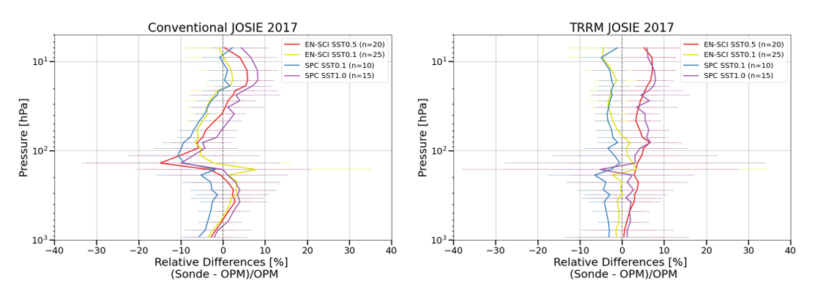

Figure S4: JOSIE 2017: Summary of the mean relative differences with the OPM for the conventional (left diagram) and TRRM (right diagram) processed ozonesonde profiles for four pairs of sonde type and SST: SPC6A/SST1.0 (blue line), EN-SCI/SST0.5 (red line), SPC6A/SST0.1 (green line), and EN-SCI/SST0.1 (brown line). The 1σ-standard deviations are represented by the horizontal lines at the pressure grid levels.

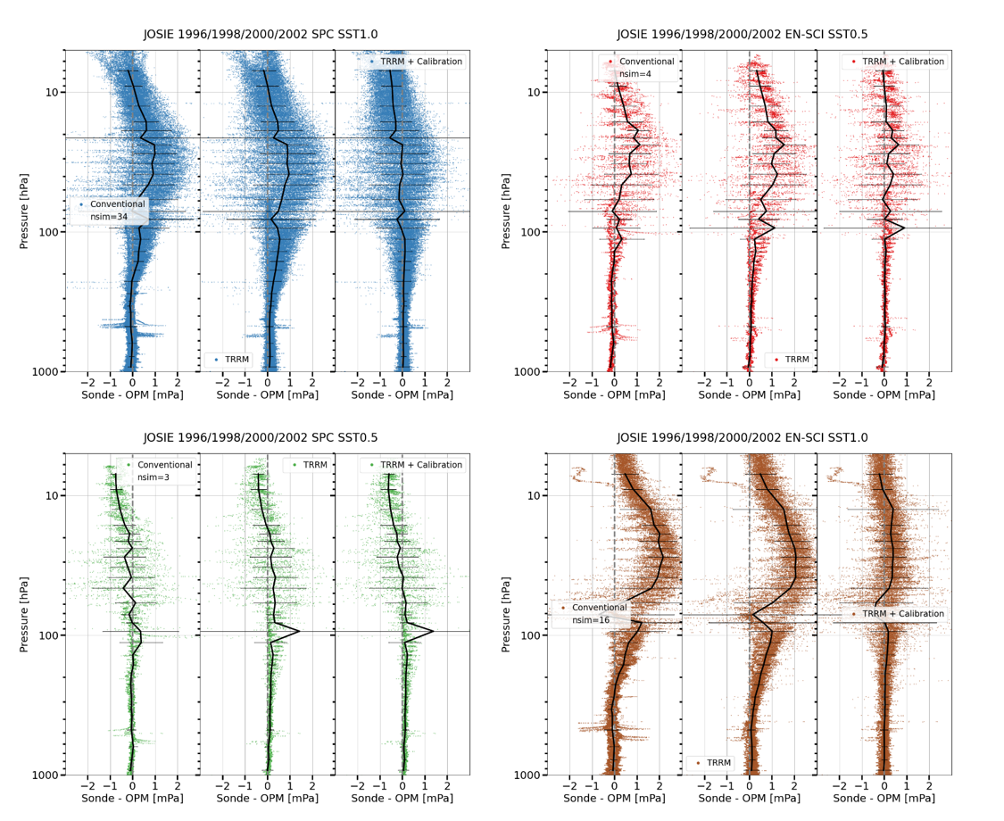

Figure S5: JOSIE 1996/1998/2000/2002: Absolute differences [mPa] with the OPM for the “conventional” (left diagrams), “TRRM” (middle diagrams), and “TRRM + application of calibration functions” processed ozonesonde profiles for four pairs of sonde type and SST, shown as scatter plots in four different colors in the panels A-D: SPC6A/SST1.0 (A: blue dots), EN-SCI/SST0.5 (B: red dots), SPC6A/SST0.5 (C: green dots), and EN-SCI/SST1.0 (D: brown dots), respectively. In each diagram for both methods the mean and 1σ-standard deviation of the absolute differences are included (solid black line).

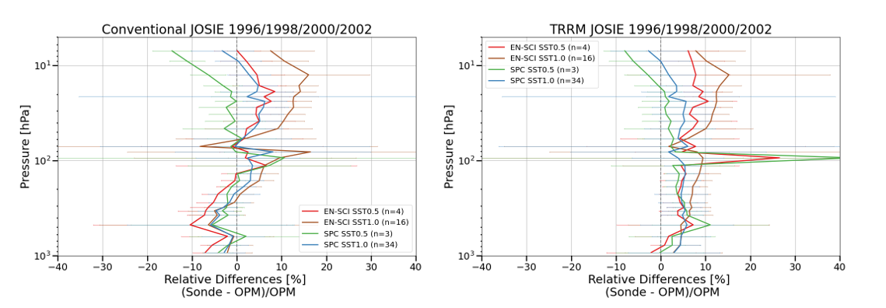

Figure S6: JOSIE 1996/1998/2000/2002: Summary of the mean relative differences with the OPM for the conventional (left diagram) and TRRM (right diagram) processed ozonesonde profiles for four pairs of sonde type and SST: SPC6A/SST1.0 (blue line), EN-SCI/SST0.5 (red line), SPC6A/SST0.5 (green line), and EN-SCI/SST1.0 (brown line). The 1σ-standard deviations are represented by the horizontal lines at the pressure grid levels.